**Learning Management System (LMS)**

Smartphones, tablets and Laptops are increasingly popular among all ages of students and they are all linked to all Educational resources through Cloud computing.

Many Educational Institutions and universities are turning towards cloud based Learning Management Systems. The Advantages of using LMS is that it reduces the cost on Learning and Development budget. For example, you won’t have to worry about printing out manuals because all the information is available online .It is a web based application on the Cloud which has many learning content. This platform would be useful for Teachers and Students all over the world as they can access the material and share their knowledge through this platform.

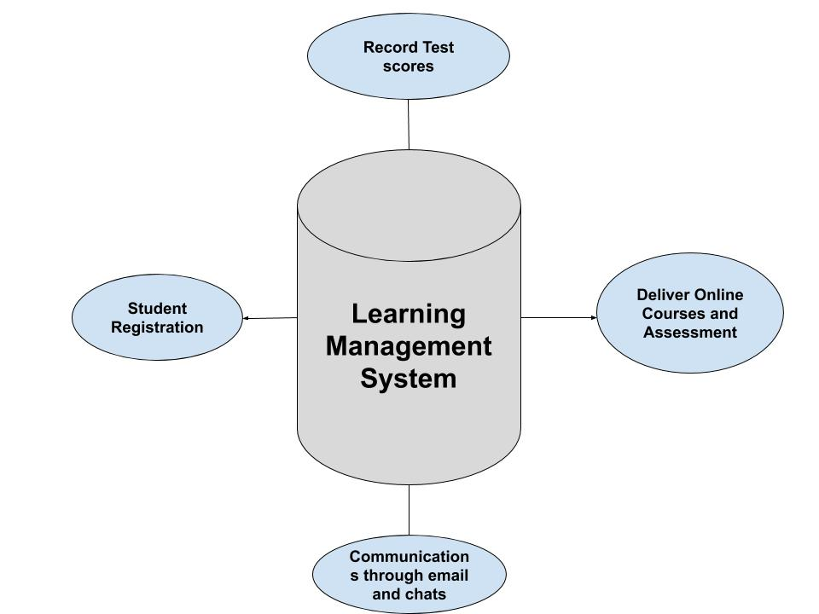

LMS Architecture

**Vision**

Our learning management system (LMS), is a software application that enables you to:

* Deliver digital learning resources and online courses to users i.e. our registered students.
* Access online courses, learning and assessment activities, and support to students anywhere at any time;
* Access the LMS inside a web browser.
* Create online courses
* Communicate online with users
* Assess, grades and feedback to users by teachers.

Our idea is to implement Cloud based Learning Management Systems. All the material will be on the server that is Cloud and Clients (Teachers and students) can access those material from the cloud.

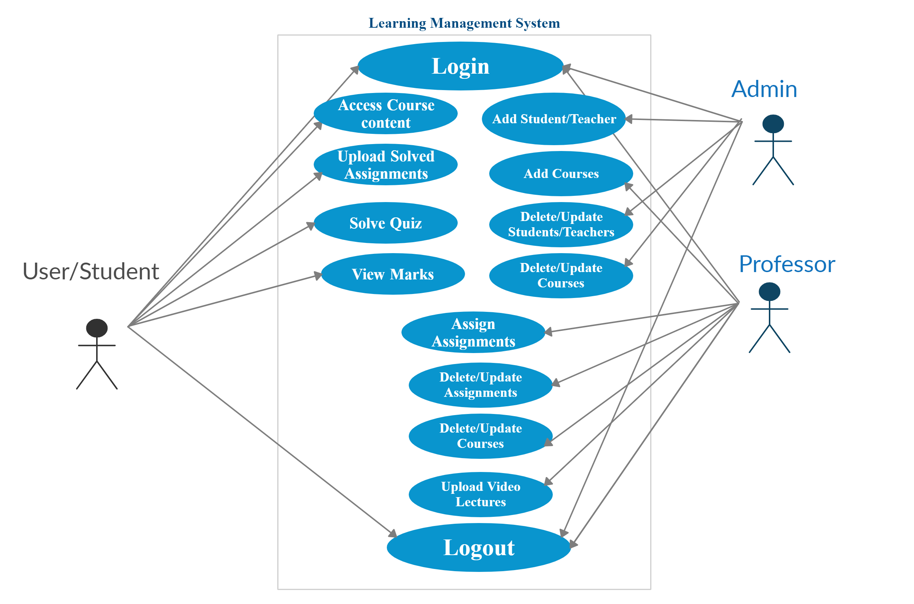

**Benefits of LMS**

The most beneficial advantage of an LMS is that it brings training and education into one centralised location, saving you time and money, whilst providing teachers and students with a tool to make learning interactive and engaging and this is the main purpose of our project.

**Technology :**

As we have the availability of Google Cloud platform in this course we following options available to implement serverless environment.

Google Cloud operates on one fundamental principle “you give us the code and we do the rest” there is no service to manage and no clusters to setup,provision or upgrade in addition the infrastructure autoscales the load demand

* Google Cloud Functions
* Google App Engine
* Google Cloud Firestore

**Google Cloud Functions:**

Google Cloud Functions is a serveless event driven computing service within Google Cloud Platform.Developers can use it to create and implement programmatic functions within Google's public cloud without having to provision the underlying cloud infrastructure such as servers and other resources.

**Usage example:**

We can write simple single purpose functions that are attached to events emitted from our cloud infrastructure and services the function will be triggered when an event being watched is fired **e.g** a file is added in the storage or a change in the database is made in that case an event will happen and in response to that the function will be triggered.

**Google App Engine:**

If we are building a web application with multiple services and want to deploy the source code while preserving all the serverless benefits then we can use Google App Engine.App Engine is a managed platform that lets you pick a language you are most comfortable with working we can use it to upload our code and run it on the infrastructure of Google.

On Google Cloud, the managed platform as a service (PaaS) is called App Engine. When you build your website on App Engine, you get to focus on coding up your features and let Google worry about managing the supporting infrastructure. App Engine provides a wide range of features that make scalability, load balancing, logging, monitoring, and security much easier than if you had to build and manage them yourself. App Engine lets you code in a variety of programming languages, and it can use a variety of other Google Cloud services.

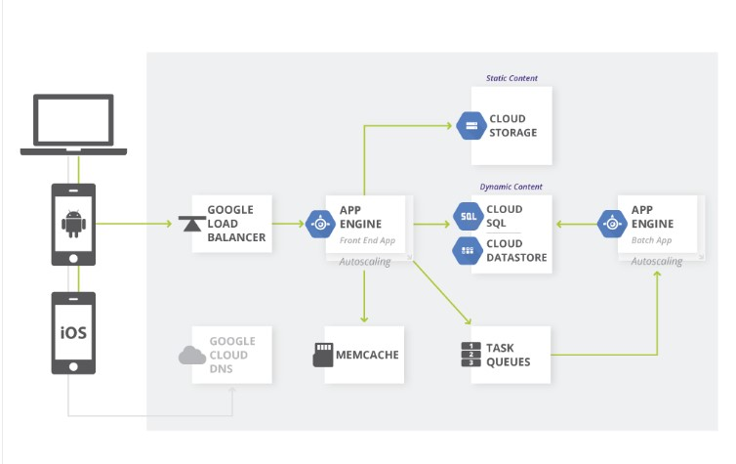

**Google Cloud Firestore**

Cloud Firestore is a fast, fully managed, serverless, cloud-native NoSQL document database that simplifies storing, syncing, and querying data for your mobile, web, and IoT apps at global scale. Its client libraries provide live synchronization and offline support, while its security features and integrations with Google Cloud Platform (GCP) accelerate building truly serverless apps.

**Usage example:**

Google recommend using Firestore in Datastore mode for databases that will be used primarily by App Engine apps

Firestore in Datastore mode is a NoSQL document database built for automatic scaling, high performance, and ease of application development.